Phishing



“Phishing” is where people are tricked into giving up secret information (like their passwords or credit card details) into a fake website that is disguised to look like a trustworthy website.

People are sent links to these fake phishing websites in emails or instant messages. How can they know if a link is safe to click on?

In this project, you will learn about the research that is being done to train machine learning systems to predict if a link is to a phishing website or a legitimate website.

This project worksheet is licensed under a Creative Commons Attribution Non-Commercial Share-Alike License

http://creativecommons.org/licenses/by-nc-sa/4.0/

Let’s start by looking at some of the parts that make up a URL (web address):

|  |  |
| --- | --- |
| port number | Which port to connect to.  If this isn’t specified, the web browser will use 80 (if the protocol is “http”) or 443 (if the protocol is “https”).  80 and 443 are the “standard” port numbers that are almost always used, but websites can use other numbers if they want. |
| host | Which web server to connect to.  This can be a numeric address with dots in (called an “IP address”) like 104.20.74.246  Or it can be a text-based host name (called a “domain name”) like machinelearningforkids.co.uk that the web browser will use to look up the IP address for (called a “DNS lookup”).  You can use https://whois.net to look up the IP address for a domain name.  This will also let you find out when a domain name was registered, and how long it is before the domain name registration expires. |
| password | The password to use to identify the user  If not specified, the web browser will not use a password. |
| username | The username to use to identify the user  If not specified, the web browser will not use a username. |
| protocol | The communication protocol that the web browser should use.  This will be “https” for secure connections, or “http” for insecure connections. |

Another thing to understand is “redirects”. Sometimes a web address will send you to another web address. For example, if you visit **https://bit.ly/39XEEfP** you end up at **https://machinelearningforkids.co.uk** because the first address is a redirect.

Redirects hide the real destination for a URL. You can join several together.

For example, if you visit **https://bit.ly/35Jnlf8** you end up at **https://www.bbc.co.uk/news** after 4 redirects.

Now look at this URL:

http://login.bankofamerica.com@www.josueizagirre.com/wp-content/cache/login.bankofamerica.com.uplogad/update.html

The web page looks like this:

This website has nothing to do with the real Bank of America.

This is a phishing URL.

How could you tell?

|  |  |
| --- | --- |
| port number | The page is using port 80 – a real banking website would be using the secure standard port 443. |
| host | The domain name for the website is www.josueizagirre.com which is not the real official domain for Bank of America. |
| username | The URL is giving the username “login.bankofamerica.com” although the web server ignores this.  Putting a username like this here is a trick to make it look like the web address is “login.bankofamerica.com”. |
| protocol | The page is using “http“ – a real banking website would be using the secure protocol “https”. |

Do you think a computer could be trained to predict that this URL was for a phishing website?

1. Go to <https://machinelearningforkids.co.uk/> in a web browser
2. Click on “**Get started**”
3. Click on “**Try it now**” and type in your username and password
4. Click on “**Projects**” on the top menu bar
5. Click the **“Copy template**” button.  
   A screenshot of a cell phone

   Description automatically generated
6. Click on the “**Import “Phishing”**” button, and then click “**Import**”.
7. You should now see “**Phishing**” in your list of projects. Click on it.  
   A screenshot of a cell phone

   Description automatically generated
8. This template project includes a sample set of training data to help save you time. Click the **Train** button to review the training data.  
   A screenshot of a cell phone

   Description automatically generated   
     
   The sample training data includes details about 1000 URLs.   
   500 were identified as phishing websites, and 500 were identified as safe, legitimate websites.  
     
   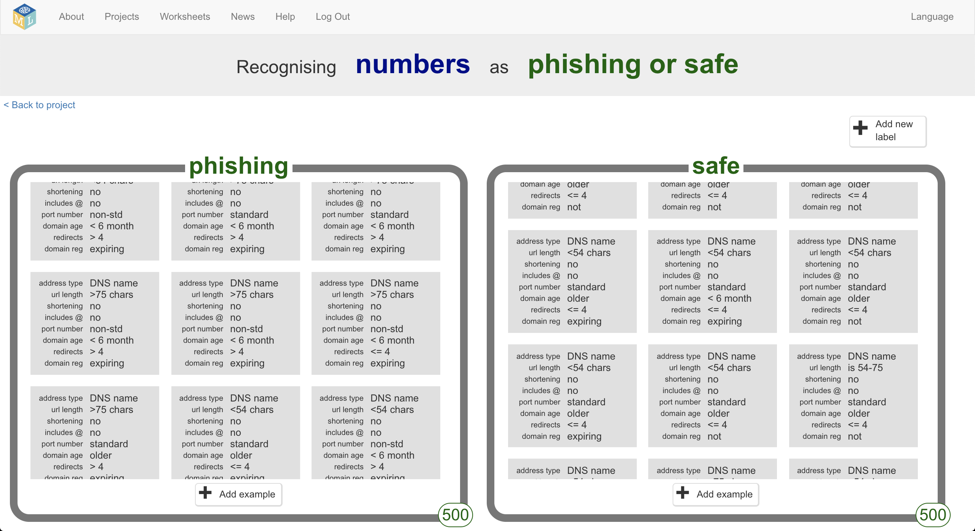  
     
   Each URL has been described using the following attributes:

| **attribute** | **description** | **possible values** | **reason** |
| --- | --- | --- | --- |
| address type | Has the host address in the URL been provided as a numeric IP address, or a text-based domain name? | **DNS name**  if the URL had a text-based domain name (like “machinelearningforkids.co.uk”)  **IP addr**  if the URL had a numeric host name (like “104.20.75.246”) | Using IP addresses is unusual, and sometimes a way to hide the real destination for a web address. |
| url length | How long is the URL? | **<54 chars**  if the URL is shorter than 54 characters long  **is 54-75**  if the URL is between 54 and 75 characters long  **>75 chars**  if the URL is longer than 75 characters long | Phishing URLs in emails tend to be longer, as it is easier to hide the suspicious part of the address if the URL is very long. |
| shortening | Does the URL use a shortening service, like bit.ly or tinyurl.com?  Shortening services use redirects to make a short version of a long web address. | **yes**  if the URL uses a recognized shortening service  **no**  if the URL does not use a recognized shortening service | Shortening services, like any redirects, make it hard to tell the true destination for a URL, so are useful to disguise a phishing link. |
| includes @ | Does the URL include the @ symbol? | **yes**  if the URL includes an @  **no**  if the URL does not include @ | Legitimate links with usernames/passwords are unusual.  Phishing links take advantage of the fact that many users don’t realize that anything before an @ is a username/password and put a pretend web address in there instead. |
| port number | Does the URL use the standard port numbers for web pages? | **standard**  if the URL uses the standard port 80 or 443  **non-std**  if the URL uses a custom, non-standard port number | Using non-standard port numbers is unusual. |
| domain age | How long ago was the domain name registered?  For example, machinelearningforkids.co.uk was registered on 17th April 2017, which you can check at whois.net | **< 6 month**  if the domain name was registered less than 6 months ago  **older**  if the domain was registered longer than 6 months ago | Phishing websites are often not around for long. They are reported and discovered quickly, so attackers create new sites and register new domains. This means a link to a domain that was registered a long time ago may be more likely to be legitimate. |
| redirects | How many redirects does the web browser have to follow to reach the final page? | **<= 4**  if there are four or fewer redirects from the URL to the final webpage  **> 4**  if there are more than four redirects to get to the final web page | One or two redirects is common to help web site developers manage their site, but more than that is possibly suspicious as a sign of trying to hide the true destination of a URL. |
| domain reg | Has the domain been registered for many years, or is it due to expire soon? | **expiring**  if the domain name is due to expire in the next year  **not**  if the domain name is not due to expire in the next year | Phishing websites are often not around for long. They are reported and discovered quickly, so attackers will only register domain names for a short time period to save their costs.  Large reputable organizations are more likely to register domain names for several years. |

For example:

http://login.bankofamerica.com@www.josueizagirre.com/wp-content/cache/login.bankofamerica.com.uplogad/update.html

would be shown in the training data as:  
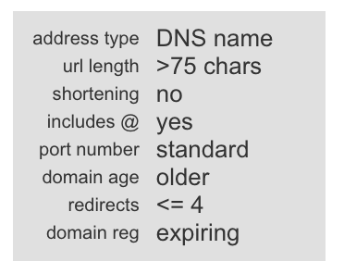

Scroll through the rest of the training data that you’ve imported.  
  
The phishing URLs from the sample project were reported by users around the world to the website **https://phishtank.com** as this is a reliable source for getting large numbers of phishing links.

The attributes chosen to describe the URLs are just a sample for your first starting project. After you’ve tried these, you’ll look at some other attributes that can be used to train better machine learning models.

1. Click on the “**< Back to project**” link in the top-left.
2. Click the “**Learn & Test**” button
3. Click the “**Train new machine learning model**” button  
   A screenshot of a cell phone

   Description automatically generated
4. Click on the “**< Back to project**” link in the top-left.
5. Click the “**Make**” button  
   A screenshot of a cell phone

   Description automatically generated
6. Click the “**Python**” button  
   A screenshot of a social media post

   Description automatically generated
7. Make a note of your “**API key**”  
   *This is like a secret code that your Python program will be able to use to access your machine learning model.*  
   A screenshot of a cell phone

   Description automatically generated *Note: The API key in the screenshot above is fake. API keys are Iike passwords. I wouldn’t share my real API key, and you shouldn’t share yours.*
8. Go to **https://github.com/dalelane/mlforkids-phishing-sample** and download a zip with the sample Python project   
   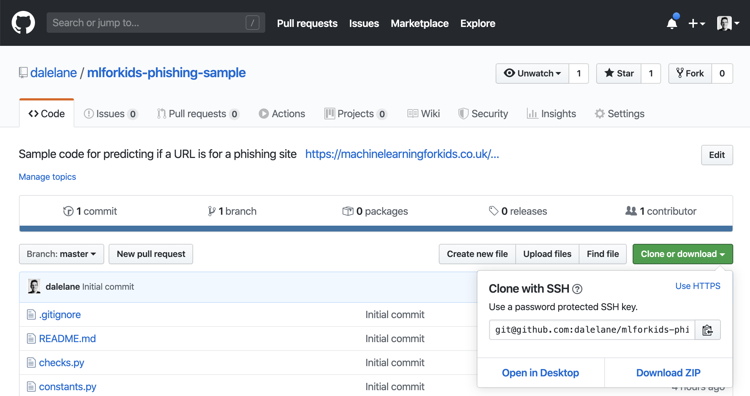
9. Unzip the project zip file
10. Open a command prompt to the folder where you’ve unzipped your project code.
11. The **requirements.txt** file lists the third-party libraries that you will need to run the code.   
    The simplest way to install all of these is to run the command:  
     **pip3 install -r requirements.txt**   
    Ask your teacher or group leader to help if you’re not sure how to do this.  
    A screenshot of a cell phone

    Description automatically generated
12. Open the file “run-test.py” in your favourite code editor, and update MLFORKIDS_API_KEY on line 4.   
    Set it to the API key you found in Step 15.   
    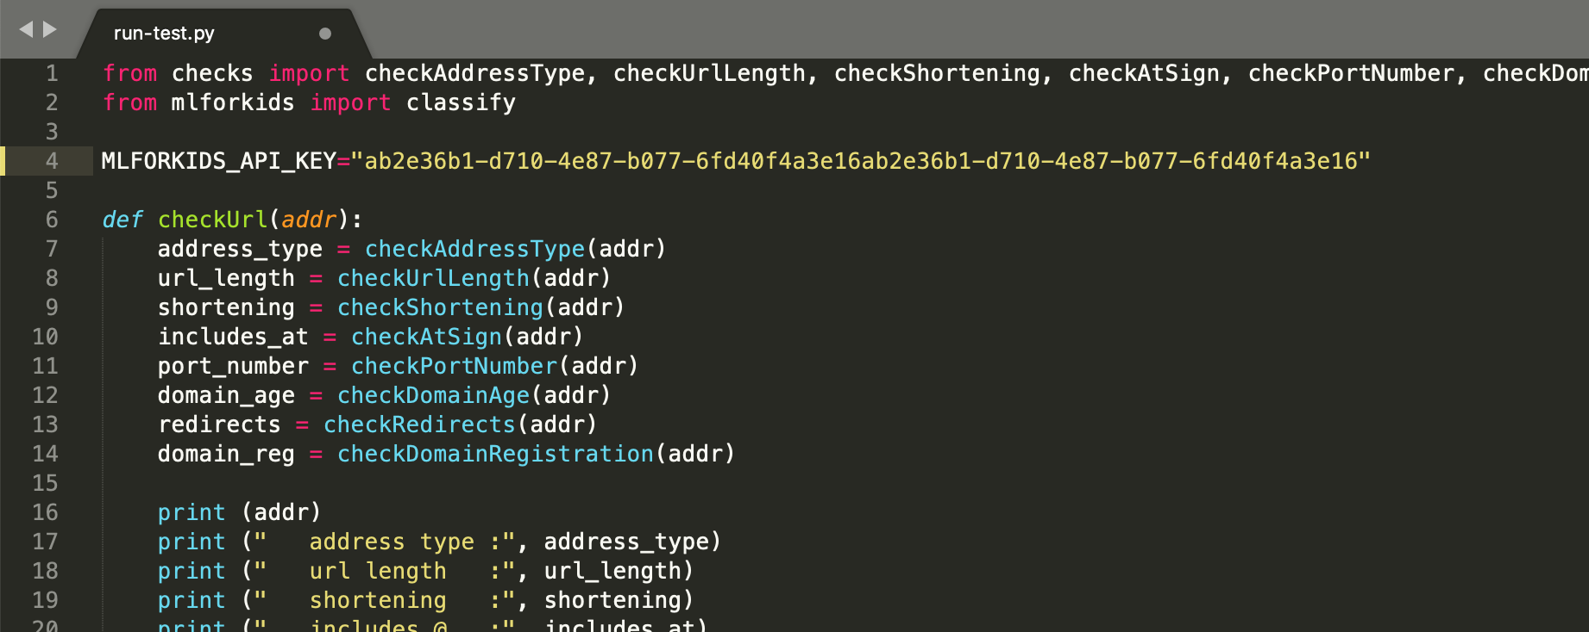
13. Run the program   
     **python3 run-test.py**

The program will use the machine learning model that you’ve trained to predict whether a variety of URLs are safe or phishing:

**https://machinelearningforkids.co.uk/help**

Hopefully it will predict that this is safe, as I send this link to people very often!

**https://www.bbc.co.uk**

This is a very old and reputable website, registered in August 1996. Hopefully it will think this is a safe link.

**https://en.wikipedia.org/wiki/Machine_learning**

The Wikipedia page for Machine Learning is another safe link.

**https://91.198.174.192/wiki/Machine_learning**

This is the same address as above – it’s the address for the Wikipedia page about Machine Learning, but using the IP address to save your web browser needing to look up the address for the Wikipedia domain name. It’s safe link to visit, but it’s unusual to describe it using the IP address, so your machine learning model might (incorrectly?) think that it is suspicious.

**https://mickey@bit.ly/35Jnlf8**

This actually points to the BBC News website https://www.bbc.co.uk/news but it uses several redirects to hide that, so your machine learning model will likely predict that it is suspicious.

**https://login.bankofamerica.com@www.josueizagirre.com/wp-content/cache/login.bankofamerica.com.uplogad/update.html**

This is a phishing website pretending to be a Bank of America page. Hopefully your machine learning model will correctly predict that it is suspicious.

**http://flinxdeicdccc.com/2612aa892d962d6f8056b195ca6e550d/tnFBsV27sc3kIMJg0Z8snqenramMHIXz.php?country=US-United%20States&lang=en**

This is another phishing website that your machine learning model will hopefully correctly recognize.

1. Edit the file “run-test.py” in your favourite code editor to test other URLs.   
   *Look at how the example URLs above were tested to learn how to use the* checkUrl *function.   
     
   Test the addresses for* ***legitimate websites*** *that you use and trust to see if your machine learning model predicts that they’re safe.  
     
   Test the addresses for* ***phishing websites*** *to see if your machine learning model predicts that they can’t be trusted. If you need to find URLs for phishing websites, https://phishtank.com is a good place to look. Find new URLs that have only just been reported as phishing sites to see how your ML model copes.*
2. Back on Machine Learning for Kids, click the “**Learn & Test**” button  
   A screenshot of a cell phone

   Description automatically generated
3. Click the “**Describe your model**” button  
   A screenshot of a cell phone

   Description automatically generated
4. Examine the visualisation for the machine learning model  
   *This shows how your model is making predictions.   
   Use the* ***Test*** *button to see how it works.*  
   *A screenshot of a cell phone

   Description automatically generated*

**What have you done?**

You’ve used a pre-prepared dataset to train a type of machine learning model called a “decision tree classifier” so that it can predict if a URL is going to be for a legitimate website or a phishing website.

You’ve used that machine learning model from a Python program, which you’ve modified so that it can make predictions about your own web addresses.

1. Plan your own project!   
   *Importing the template project means you didn’t have to decide which features the machine learning model should use.   
     
   Your project used eight features (described in Step 8 above).  
     
   Think about how you could improve your machine learning model by adding additional features.   
     
   What other attributes about web sites do you think would help your machine learning model to be better at recognizing phishing URLs?   
     
   The following pages include links to some research projects on this topic which might help to give you some ideas.*

**Machine Learning research about Phishing**

Training machine learning models to recognize phishing URLs is an active topic in ML research.

Try looking at some of the papers listed below.

Even if you don’t understand everything they say, running your own experiment should help you get the general idea.

Do any of these papers give you an idea for your own project?

[**https://ibm.biz/phishing-hassan**](https://ibm.biz/phishing-hassan)

This paper describes Hassan’s research into 30 different attributes of phishing links. Twelve of these are based on attributes of the URL, as you did in your project.

Some attributes described are based on the way the link was displayed. For example, if the phishing link was in an email, was the URL displayed when you hover a mouse pointer over the link?)

[**https://ibm.biz/phishing-rajab**](https://ibm.biz/phishing-hassan)

This paper describes Rajab’s research into how to tell which features are the most useful to recognize phishing URLs.

They identified the protocol (whether the page starts with http or https) and whether the SSL certificate for a website is signed by a trusted source as being two of the most significant attributes to use.

[**https://ibm.biz/phishing-joshi**](https://ibm.biz/phishing-joshi)

Joshi & Pattanshetti describe 48 attributes that they found to be useful, including whether the page contains secure forms, whether forms on the page try to send emails, whether the icon on the address bar looks valid, and many more.

[**http://ibm.biz/phishing-basnet**](http://ibm.biz/phishing-basnet)

Basnet, Sung & Lui describe how they reviewed 177 different attributes of URLs to identify the most useful to train a machine learning model.

Some of these looked at the contents of the web pages themselves, not just the URL address of them, such as counting the number of links on the page, whether the page contains iframes, whether it has password fields in it, and so on.

[**https://ibm.biz/phishing-mohammad**](http://ibm.biz/phishing-mohammad)

Mohammad, Thabtah & McCluskey describe a variety of features they identify as useful, some based on the URL like you have done, but some based on the use of JavaScript on webpages, and some using data from external sources like Google, PhishTank, Alexa, and others.

They describe the attributes they used very clearly, and you should recognize several of these from features in your project.

[**https://ibm.biz/phishing-shirazi**](http://ibm.biz/phishing-shirazi)

Shirazi, Haefner & Ray build on the Mohammad et al paper described above, and say how they identified the 10 most useful attributes they used to make “Fresh-Phish”.

One of these was the Google ranking for a URL, relying on Google to have a high rank for legitimate websites.

[**https://ibm.biz/phishing-whittaker**](https://ibm.biz/phishing-whittaker)

Whittaker, Ryner& Nazif describe how Google have evaluated URLs to identify phishing pages.

They describe features such as the presence of terms like “customerservice” in the URL, which they found to be more common in phishing sites.